# Swagger Documentation + Spring Boot || REST API Documentation

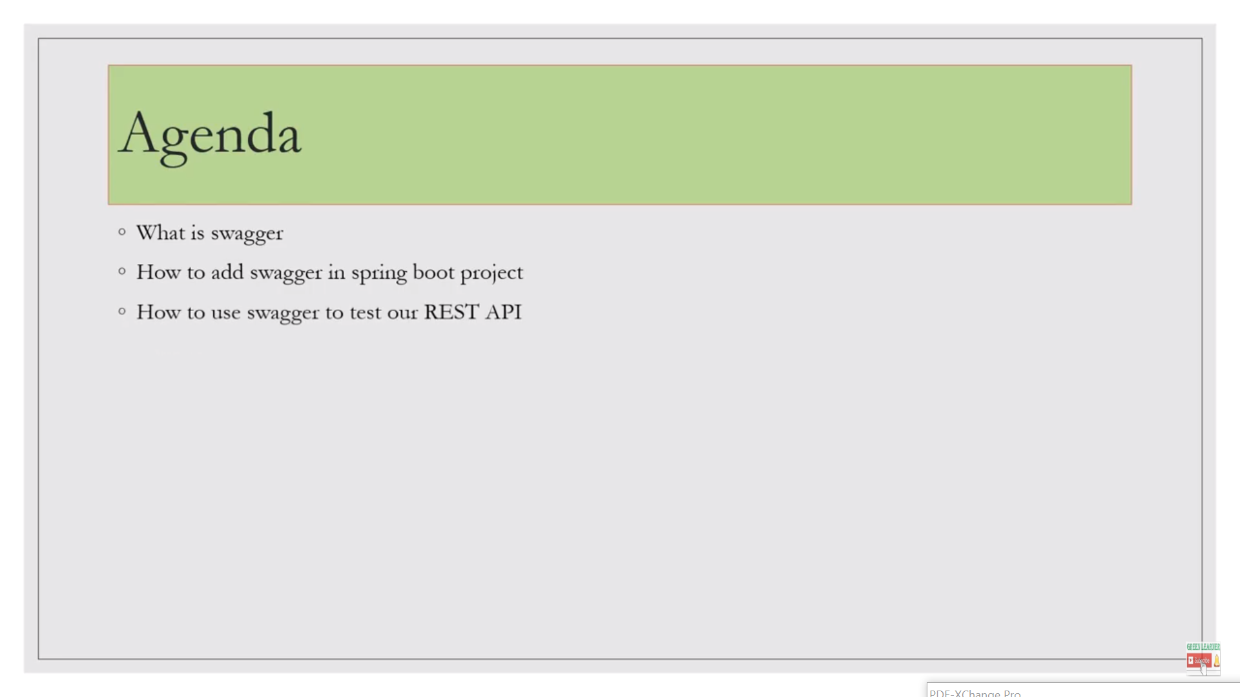

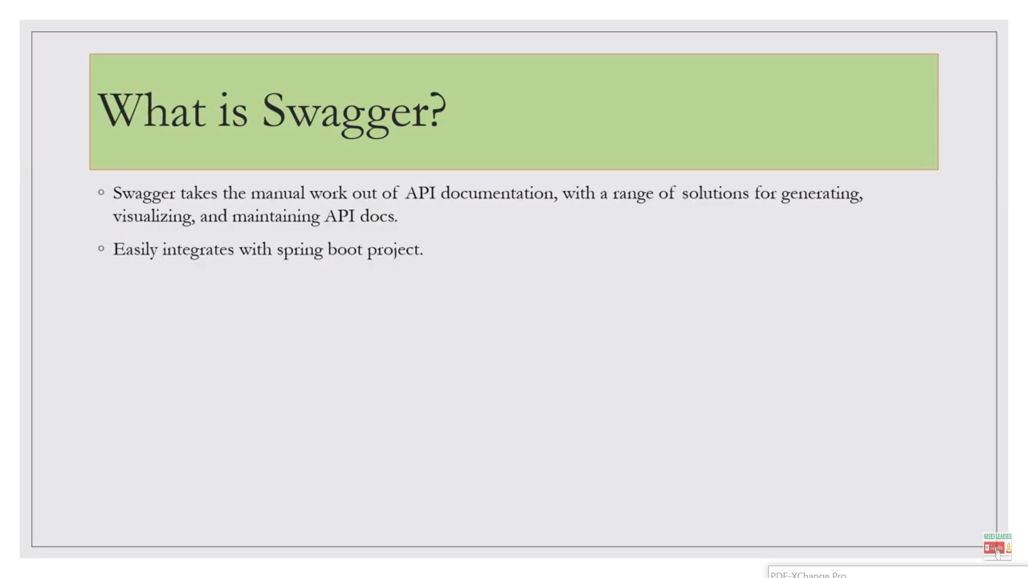

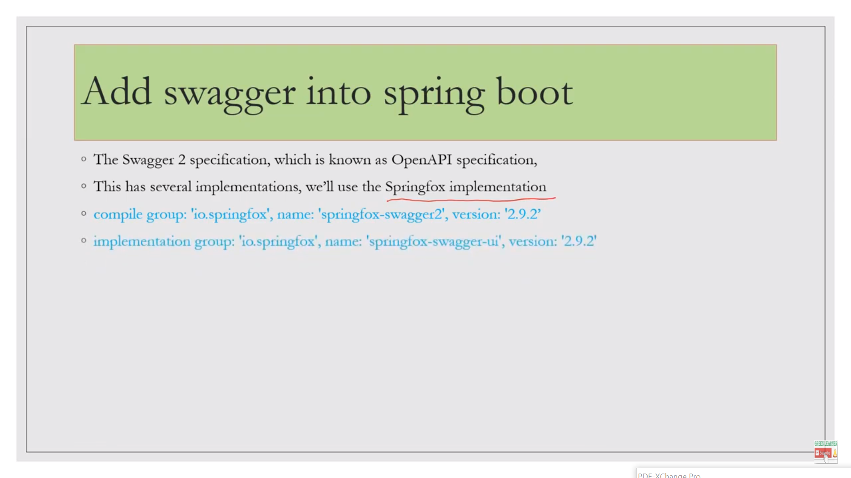

1sr dependency to configure swagger in our app and 2nd to visualizing api docs…

compile group: 'io.springfox', name: 'springfox-swagger2', version: '2.9.2'

implementation group: 'io.springfox', name: 'springfox-swagger-ui', version: '2.9.2'

@Configuration annotation detected automatically at starting of application... @EnableSwagger2

It is enabling the swagger for my api…

plugins **{** id 'org.springframework.boot' version '2.3.1.RELEASE'  
 id 'io.spring.dependency-management' version '1.0.9.RELEASE'  
 id 'java'  
**}**group = 'com.always.learner'  
version = '0.0.1-SNAPSHOT'  
sourceCompatibility = '1.8'  
  
repositories **{** mavenCentral()  
**}**dependencies **{** implementation 'org.springframework.boot:spring-boot-starter-web'  
 testImplementation('org.springframework.boot:spring-boot-starter-test')  
 developmentOnly("org.springframework.boot:spring-boot-devtools")  
 //Add Swagger2 dependencies  
 compile('io.springfox:springfox-swagger2:2.9.2')  
 compile('io.springfox:springfox-swagger-ui:2.9.2')  
 compile group: 'io.swagger.core.v3', name: 'swagger-maven-plugin', version: '2.1.3'  
  
**}**test **{** useJUnitPlatform()  
**}**

swagger invoke through Docket…

for spring api documentation swagger is an entrypoint…

package com.always.learner.usermanagementapp.config;  
import org.springframework.context.annotation.Bean;  
import org.springframework.context.annotation.Configuration;  
import springfox.documentation.RequestHandler;  
import springfox.documentation.builders.RequestHandlerSelectors;  
import springfox.documentation.spi.DocumentationType;  
import springfox.documentation.spring.web.plugins.Docket;  
import springfox.documentation.swagger2.annotations.EnableSwagger2;  
  
  
@Configuration  
@EnableSwagger2  
public class SwagConfig  
{ @Bean  
 public Docket swaggerConfig()  
 {  
 return new Docket(DocumentationType.*SWAGGER_2*).select()  
 .apis(RequestHandlerSelectors.*basePackage*("com.always.learner.usermanagementapp"))  
 .build();  
 }  
}

it scan the base package and whatever resource or endpoint is there it will document that…

<http://localhost:8082/swagger-ui.html>

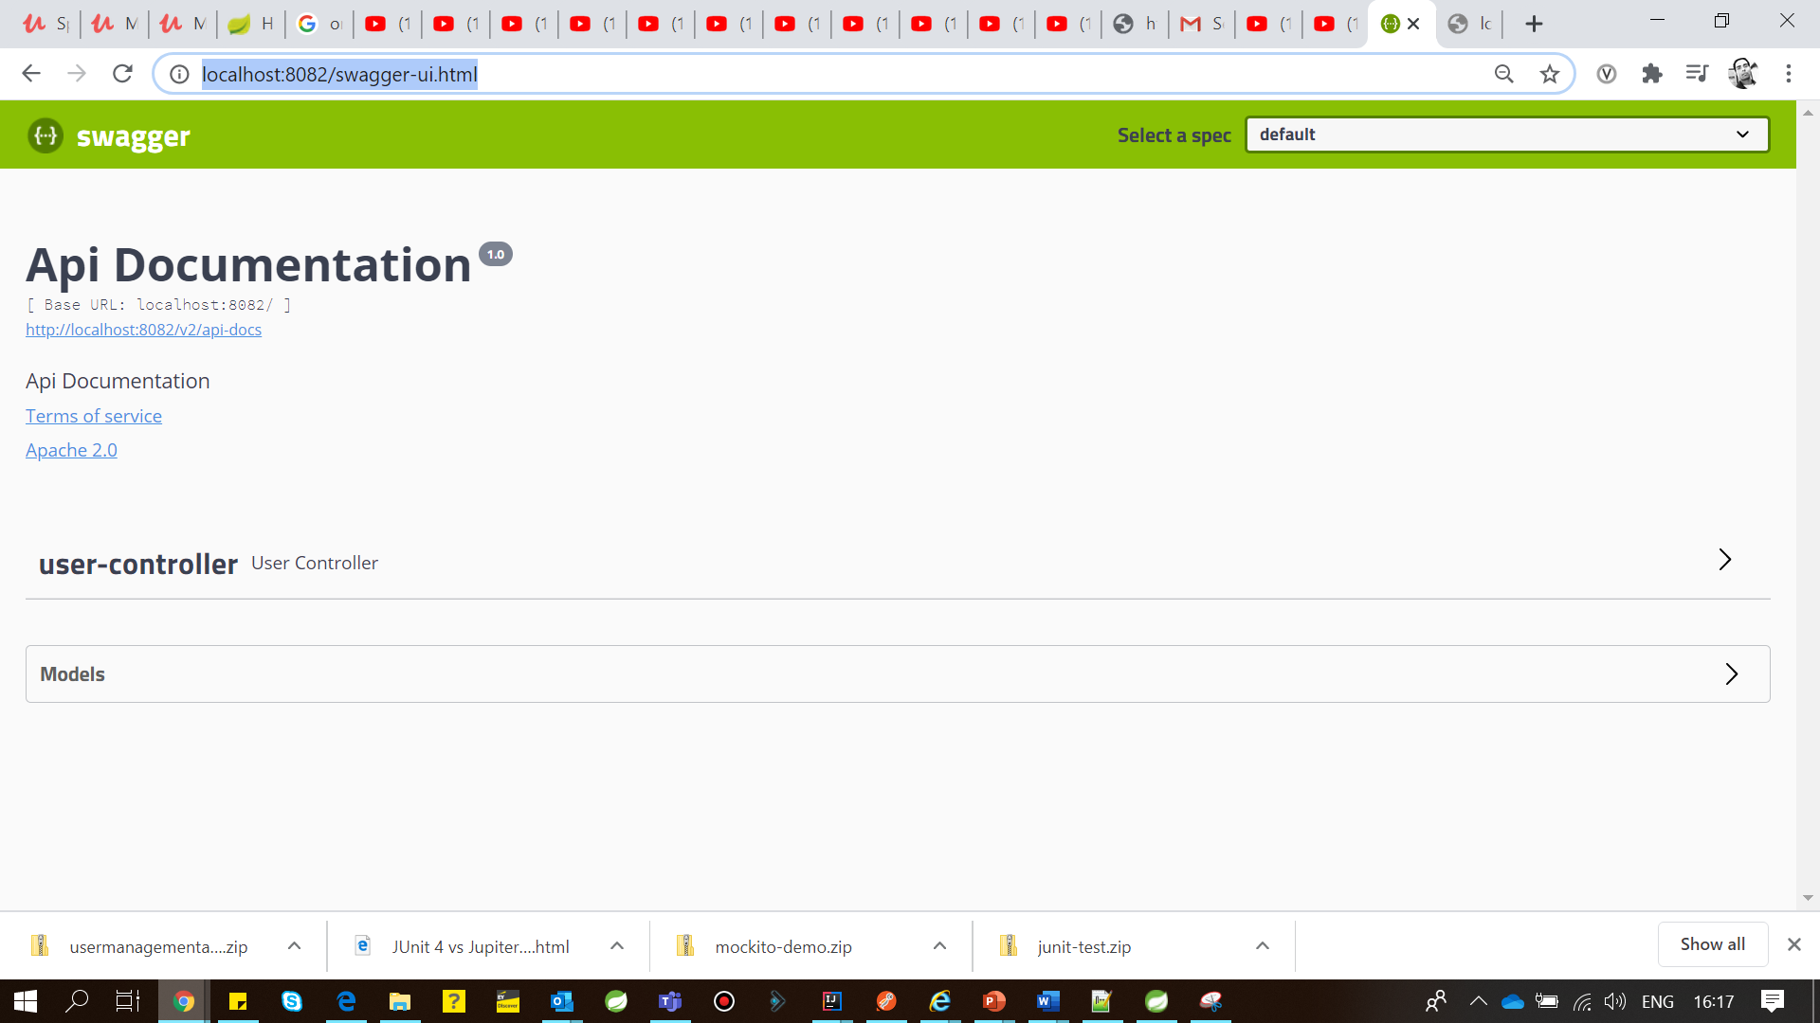

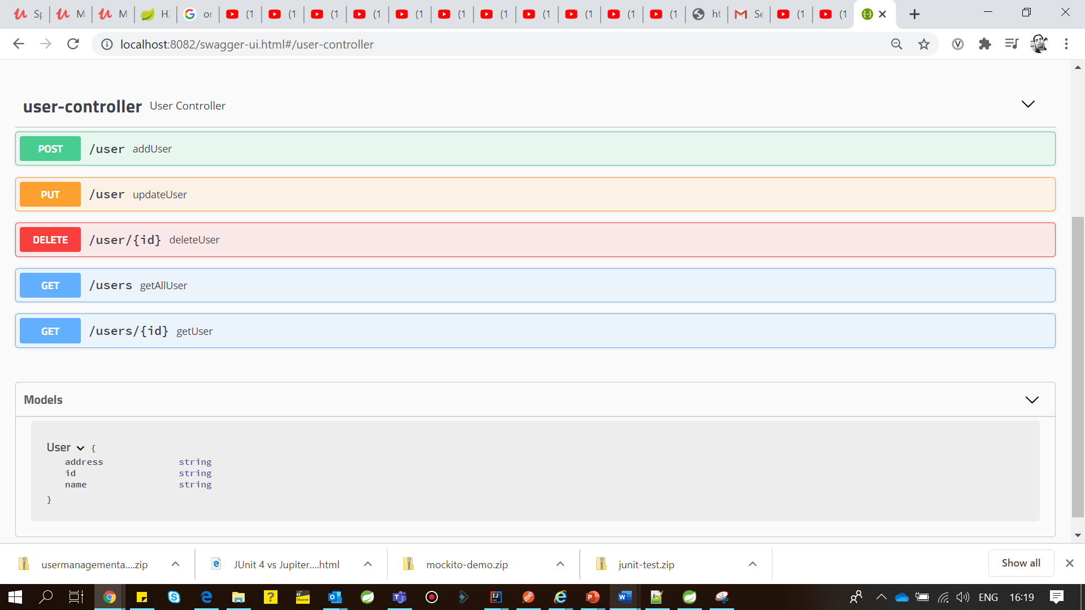

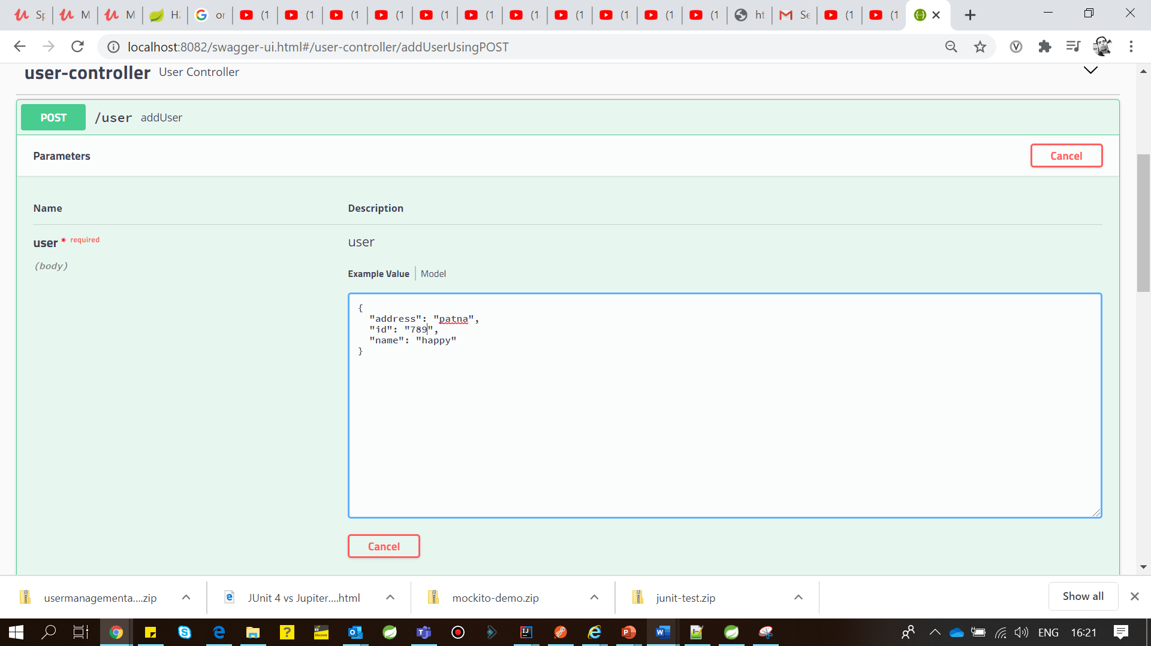

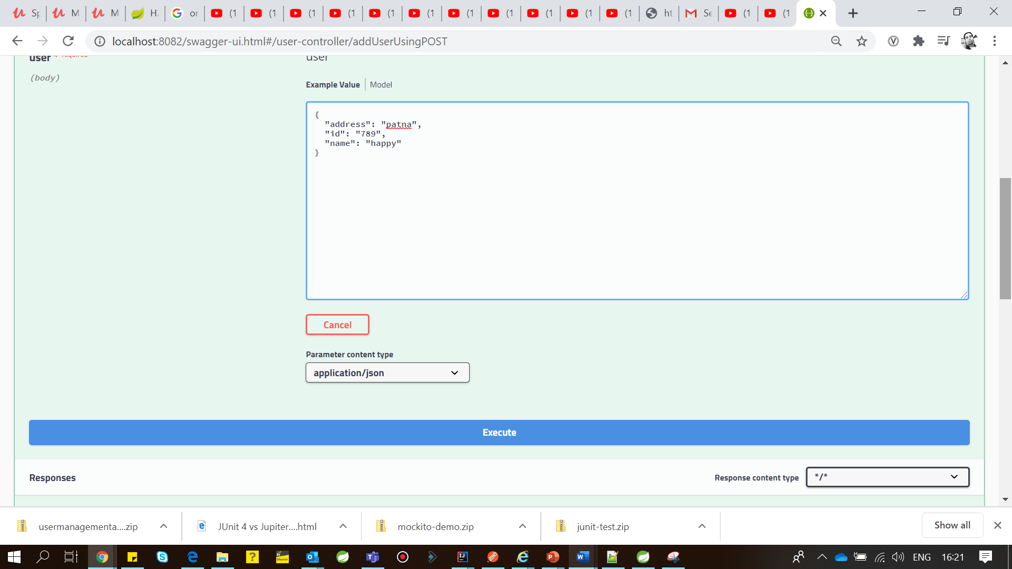

Before changing…

